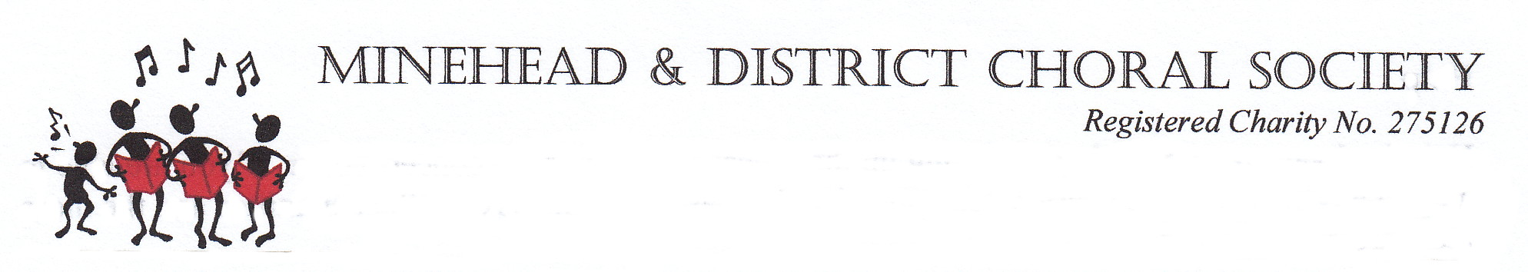

Minutes of Committee meeting held at Manor Farm, Wootton Courtenay on 12th May 2025 at 7.30pm.
- Apologies for Absence – Jill Strong and Val Stuart
2. Minutes of previous meeting approved by committee and signed by Chairman
3. Matters arising - none
4. Chairman’s Business.
Malcolm McNeil, a long standing member of the Society ,has sadly passed away, Penny will be going to funeral so she will represent the Society.
David Joysey, one of our guest tenors, has suggested that David Hedges could be a useful contact for future concerts as he has links with orchestral players.
The Methodist Church may be holding Christmas Tree events in future which will impact the amount of space available for Choir and orchestra. This will need to be taken into consideration when planning our concerts.
Recruitment was discussed and Val Stuart has forwarded some suggestions from Making Music which the Committee will take a look at. Jennie suggested a Social Media campaign prior to September might drum up a few new singers. She will approach Alex Gardener for help as Alex is experienced in this field. It was felt that a concentrated campaign would be more effective than a drip feed approach. It was suggested that Unity’s excellent recording of our performance of the Mozart Requiem might be used in some way.
David has received a message from Tom Gliddon in which he has put forward some suggestions for the committee to consider regarding future concerts and recruitment. The committee were glad to receive input from a member and his ideas were included in the discussions throughout the meeting.
5. Treasurer’s Report.
Jennie reported that thanks to a very successful Spring Concert the Bank Balance is healthier than she was anticipating. She cited several reasons for this; increase in ticket prices, good attendance figures and generous donations. We have also received grants and had two lots of Gift Aid this year. Jennie pointed out that this was exceptional and that the Society still need to find ways to increase it’s income going forward.
It was agreed to put forward a motion at the AGM to increase the annual subscription by £5.00 to £85.00. The decision to only increase by £5.00 was taken to ensure we don’t lose members due to the cost. It was suggested that members who are able to pay more be encouraged to do so by increasing their BACS payment.
6. AGM Arrangements.
Catering to be organised by Tina, assisted by Unity.
Penny to send out a reminder / invitation to members.
Daphne, our President, hopes to attend but has given Penny her report in case she is unable to.
Election of Officers:-
Treasurer and Secretary to be proposed.
New recruits to be proposed.
Rest of committee to be voted en bloc.(Including Making Music Rep Val Stuart as she is a Trustee)
The Chairman will be selected by the Committee at the next meeting.
7. Next Concert.
Audrey reported that the Library have been unable to source Rubino’s American Christmas which was to be part of our Christmas Concert. There is another Rubino selection available which Marcus will take a look at. The possibility of adding readings and solos by choir members was suggested to give variety to the programme.
8. Dates.
Next term begins September 9th and there will be a Committee meeting the day before in the Spinners Suite at Yarn Market Hotel, Dunster.
The winter concert will be held on 29th November.
Next AGM 19th May 2026.
Spring Concert 28th March 2026.
9. AOB.
Ways to augment the tenor and bass sections were considered and Angela informed the committee that Taunton Minster is attracting a lot of singers under the direction of Miles Quick. He might be able to suggest some suitable singers to join us for a few rehearsals and concerts in the future.
A lot of time was spent discussing the content for future concerts and Marcus was grateful for the many different suggestions put forward. He will arrange a meeting of the Repertoire sub-committee at some point to look at the various options.
The idea of fundraising was raised possibly in the form of a Cream Tea or maybe a quiz. These would help fill the coffers and would be good social events. David will raise the ideas at the AGM and see if there is any interest.
There being no further business Marcus was thanked for his kind hospitality and the meeting was closed at 9.23pm.
Chairman to sign.

